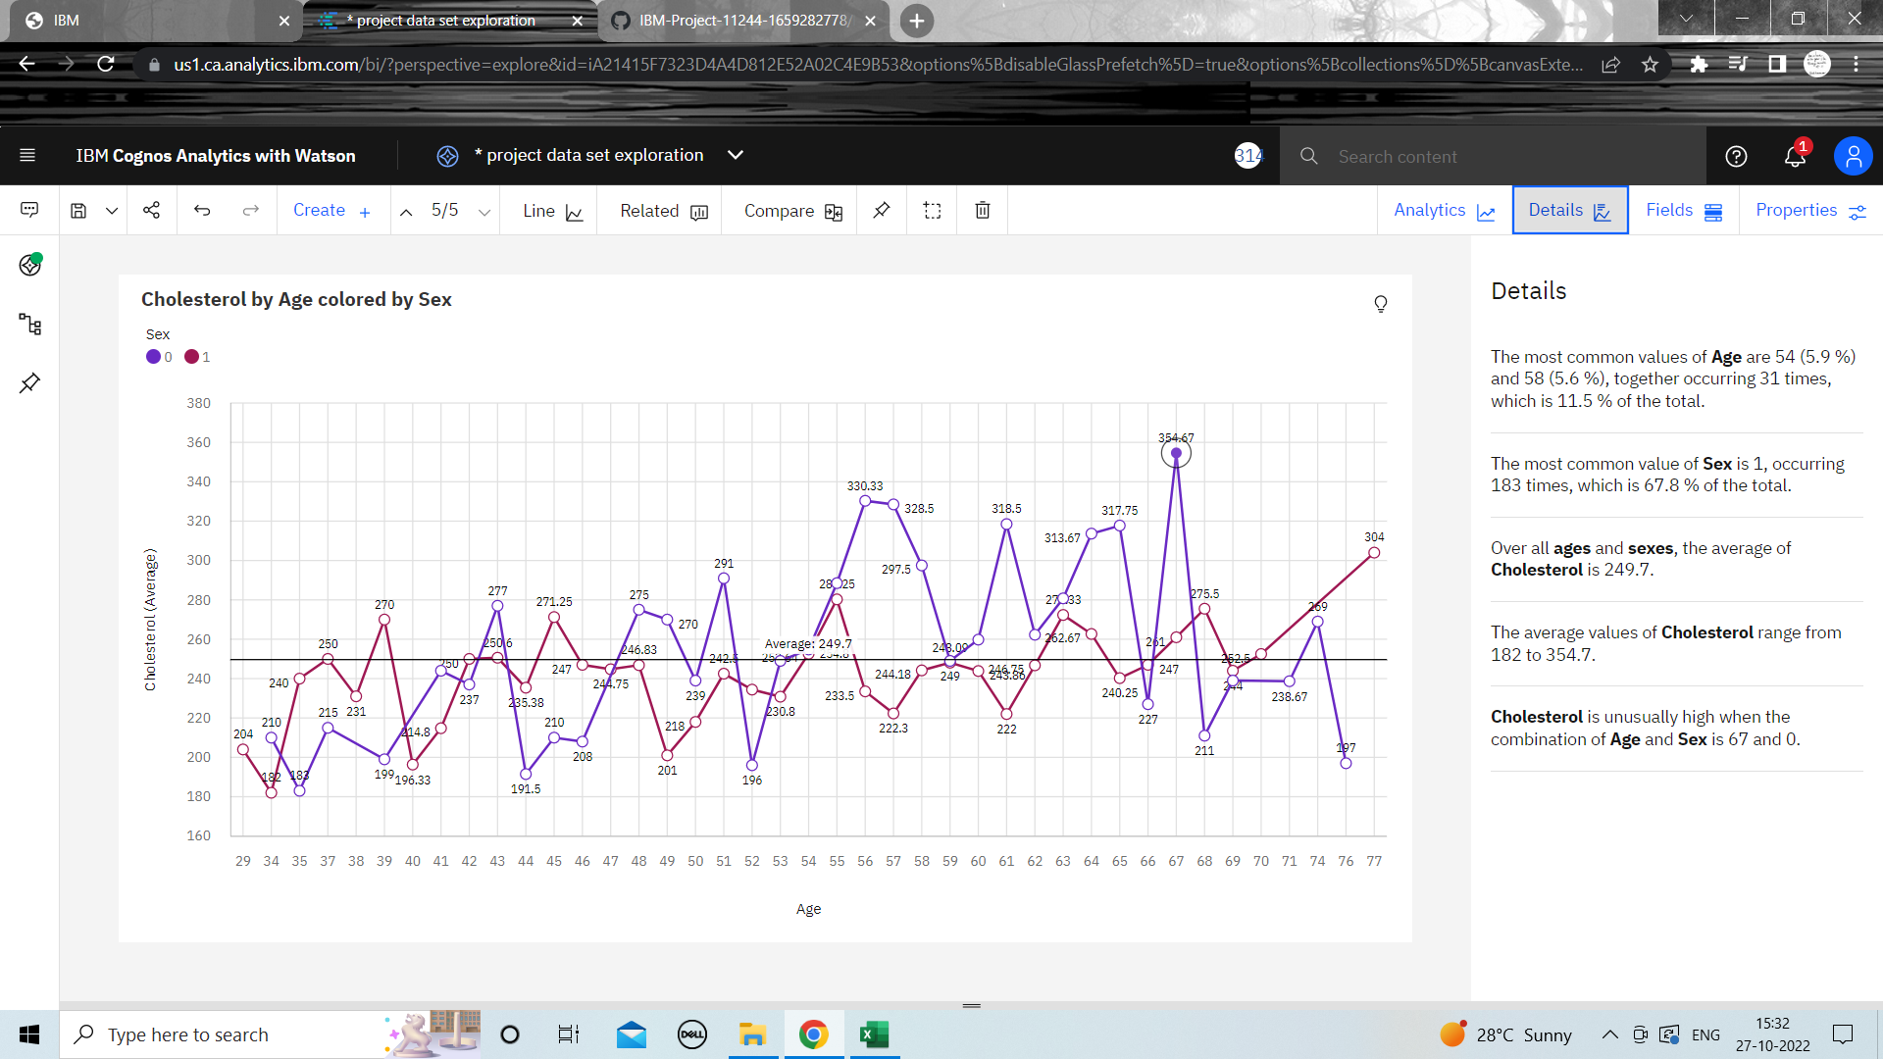**Exploration of Cholesterol vs Age and Gender**